JIRA:

Step 1: Open jira and do the setups
Step 2: BA will do this: Ask chat gpt to create epics and user stories with descriptions
- Go to back log –
- 1st create sprint : click on create sprint
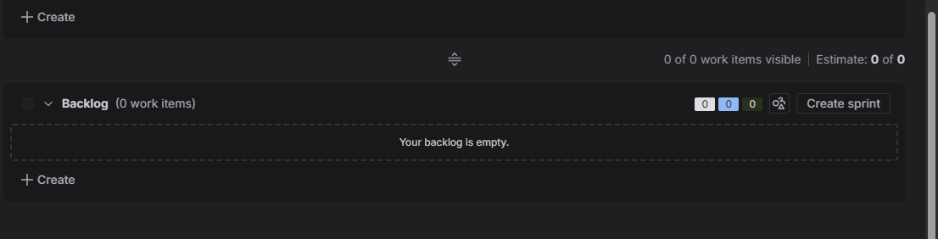
Note: In backlog create sprint create, how many sprint u need for the project then min that later we will come
- 2nd Now Create backlog: click on create
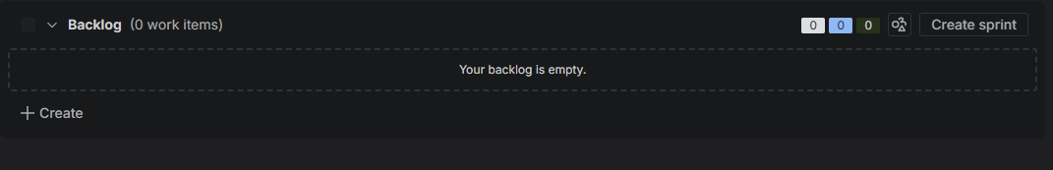
Like this it will come
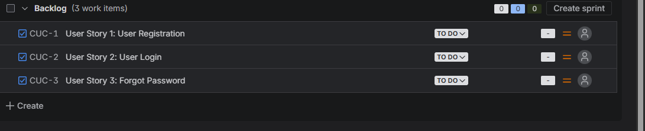

- 3rd Create Epic: click on create blue

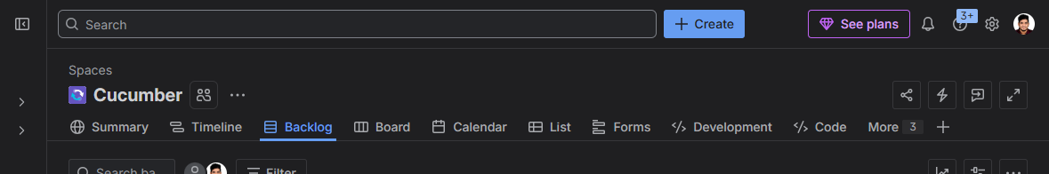
Like This will come below add summary as of now
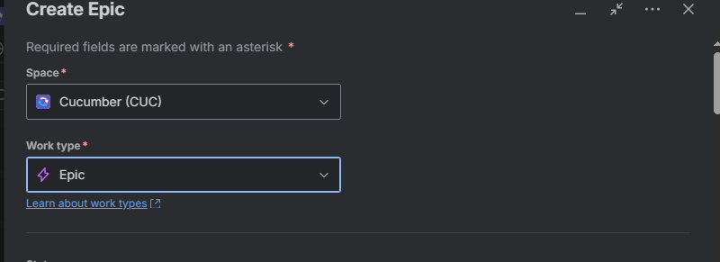

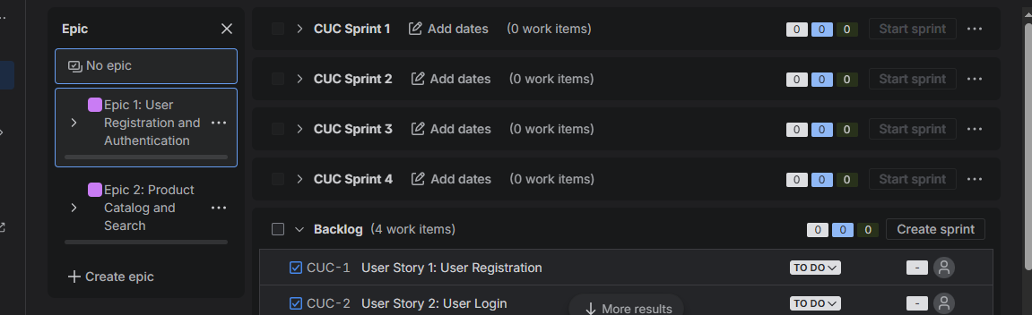

- 4th Now merge User stories with epic

Note: For that go to user story move the mouse u will see option add epic click that and add respective epic

- 5th Now Move user story into sprint

- 6th Now add descriptions in user stories
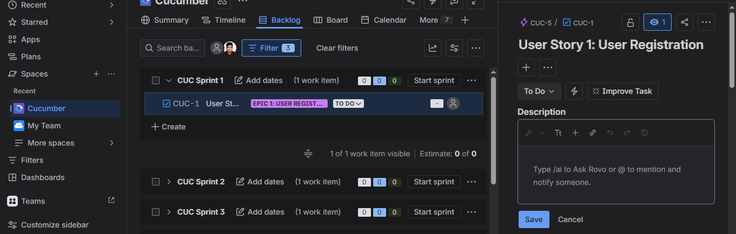

- 7th click start sprint set due date – start
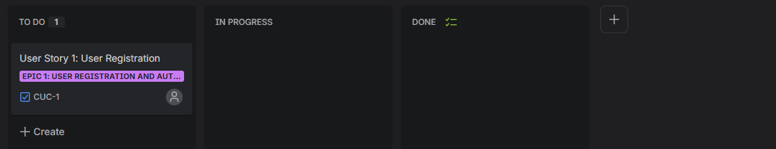

Note: After this it will come to todo state from here only we will work

- 8th Complete print:

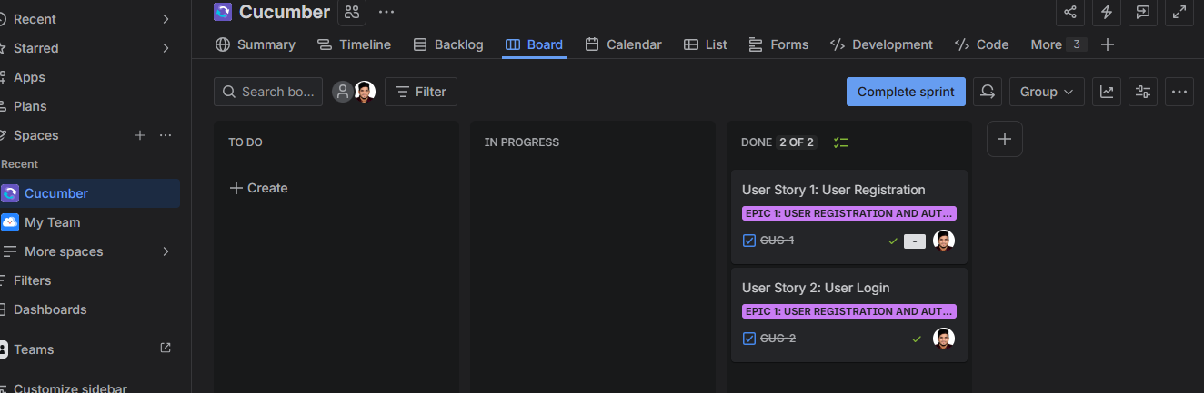

Then start next sprint

